DANCE PROGRAM
Arts and Languages Department

Fall 2022

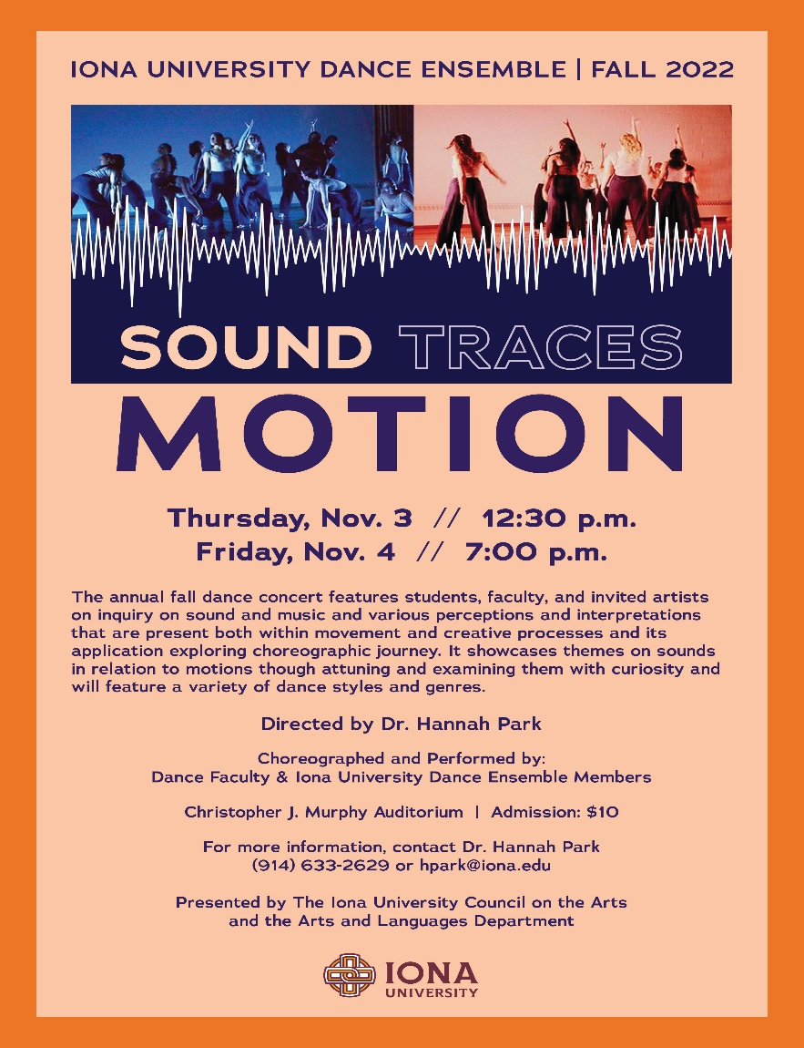

Sponsored by the Council on the Arts & the Arts and Languages Department
Director’s Notes
As things become more normal after the pandemic, it is clear that creativity and dance can be a strong medium to re-empower, re-connect, and re-celebrate oneself and the community. Dancers often find inspiration in this endeavor through various sounds and music. This semester, the Iona University Dance Ensemble members used dance and creative processes related to the details of sounds and music to inspire their movement. As a director, it was an honor to witness the dancers embodying sounds and relating them to their own intentions behind the dances.

Throughout the process, the dancers sought to explore the specifics of music, sound, and their meanings through traces of motion that related to their reflections on self, others, and matters that were important to them. This semester’s repertory includes a contemporary ensemble piece inspired by Latinx musical styles and sounds of nature that highlights the idea of joyous feelings derived from rhythm both in music and nature. The ensemble’s dance film-based piece shows each dancers’ physical response to music and sounds in a chosen space. The program also includes a African diaspora-based contemporary piece choreographed by Prof. Andrea Markus that explores different movement qualities from Africa and the diaspora that flow like water and are grounded in the earth. A work by our continuing guest jazz dance artist, Ms. Lisa Harvie, is performed to the well-known jazz standard “I Won't Dance” for which the arrangements and vocal choices changed over the years, the sounds of the music found new life, and the song remains a joy to dance. The program also includes solos choreographed by the student dancers and their interpretations of music that they resonate with.

We congratulate all the performers for their work as creative artists, thinkers, and collaborators. We thank the Council on the Arts and the Arts and Languages department for making this program possible.

Finally, I invite you to witness the embodiment of various meaningful music and sounds from the perspectives of our performers and choreographers. It is my hope that the program will help you appreciate dance as an art form and a communicative tool that speaks about the beauty of life and human experiences.

As always, the Iona University Dance Ensemble expresses its deep gratitude for your continued generous support.

Sincerely Yours,
Hannah Park
Dr. Hannah Park - Director of Iona University Dance Ensemble

Program

- Sound, Traces, and Motion

Director: Dr. Hannah Park

Videographer: Dr. Gillean Lee

Choreographers/Performers:
Leslie Aguirre, Haley Aversa, Samantha D’Agostino, Darianny Mercedes, Aaliah Morales, Ariel Posner, Jennifer Romain, Christele Romulus, Kayla Torres, Victoria Shinnick, Ariana Tamayo, Aamirah West, Avia Willis

Music: Weird Fishes/Arepeggi by Rodrigo y Gabriela

Note: This dance uses a co-created dance film that incorporated the movement train structure (inspired by Mitchell Rose’s Exquisite Corps) to explore the physical embodiment of sounds through experimentation with limbs, gestures, and actions. The process involved reflecting on self, connecting with senses, and being inspired by the space in which the dance was created. The performance is used as an introduction to each dancer as well as each dancer’s explorations on dialoguing with themselves on the screen. Some compositional ideas incorporated are articulations of Elements of Dance related to body manipulation, mirroring, exploration of pathways, explorations of entrance and exits, and varied shape and motion possibilities.

- I Won't Dance

Choreographer: Prof. Lisa Harvie

Performers: Haley Aversa, Samantha D’Agostino, Jennifer Romain

Music: I Won’t Dance by Erin Boheme (Feat. District 78)

Note: This piece is performed to the well-known jazz standard "I Won't Dance" which was originally written by Oscar Hammerstein II and Otto Harbach, and subsequently re-written by Dorothy Fields. It was famously used for a Fred Astaire and Ginger Rogers dance and has been recorded by numerous artists over the years. The arrangements change, the vocal choices vary, and the sounds of the music find new life, yet the song remains a joy to dance... despite stating otherwise!

- Immerse & Unfold II

Choreographer/Performer: Dr. Hannah Park
(Dance on Screen)

Music: Earth by Garth Stevenson

Note: The piece, originally presented at the Somatic Conference and Dance Performance Festival on July, 2022 in Geneva NY, uses the somatic lens to explore the function of the body and the mind and their relationships to the different expressive capacities of our bones, muscles, organs and ligaments coming from the details of the sounds in the music score.

- Inner and Outer Rhythm

Choreographers: Dr. Hannah Park in collaboration with dancers

Performers:
Leslie Aguirre, Haley Aversa, Samantha D’Agostino, Darianny Mercedes, Aaliah Morales, Ariel Posner, Jennifer Romain, Christele Romulus, Kayla Torres, Ariana Tamayo, Aamirah West, Avia Willis

Music: Bright Rumped Atilla Bird Sounds & Calls by Sound Ideas, Birdwatching at Inner Forest by Penguin Café Mix edited by Gillian Lee

Note: This dance explores individual and collective physical ideas of joy inspired by rhythms of nature and music.

- Gravitational Force

Choreographer/Performer: Victoria Shinnick
(On Screen Thursday Nov. 3rd, live on Friday Nov. 4th)

Music: Gravity by Sara Bareilles

Note: The dance highlights the power of strength and its various colors.

- Home

Choreographer/Performer: Haley Aversa

Music: Oceans (Where Feet May Fail) by Hillsong UNITED, Zion (Deluxe Edition) Edited by Haley Aversa

Note: This dance explores re-finding one’s faith and its power in overcoming various obstacles and challenges faced.

- Life
Choreographer/Performer: Jennifer Romain
Music: Sellah by Kanye West, edited by Jennifer Romain.
Note: The dance explores contrast and experimentation with focus on slow and minimalistic gestures highlighting personal meanings on life and its possible complexities.
- Tuning In
(Dance on Screen)

Choreographers/Performers:
Dr. Hannah Park, Prof. Lisa Harvie, Prof. Andrea Markus

Videographer: Dr. Gillean Lee

Music: Modular Body 1 by Machinefabriek

Note: This screen dance aims to express collective voices and identity of the faculty/artists involved with the program through individual site-specific explorations on a given space with a focus on the embodiment of multiple senses.

- From Water

Choreographer: Prof. Andrea Markus

Performers:
Leslie Aguirre, Haley Aversa, Samantha D’Agostino, Darianny Mercedes, Aaliah Morales, Ariel Posner, Jennifer Romain, Christele Romulus, Kayla Torres, Ariana Tamayo, Aamirah West, Avia Willis

Music: Agua by Kalunga and Yole by Jason Hann. Mixed by Ace

Note: This piece is about exploring the different movement qualities from Africa and the diaspora that flow like water and are grounded in the earth and desires. “Life is a cabaret old chum, come to the cabaret!”

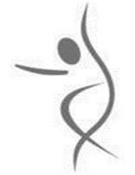

Thank you for your support for the Art

Biographies

Iona University Dance Ensemble (IUDE) Fall 2022 Dancers
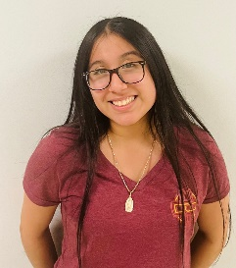
Leslie Aguirre is a sophomore from the Bronx majoring in Psychology. This is her first semester with the Iona College Dance Ensemble. Leslie has been dancing for over eight years. She has experience in multiple styles of dance such as Contemporary, Jazz, Ballet, Pom, Hip-Hop, Modern, and Acrobatics.
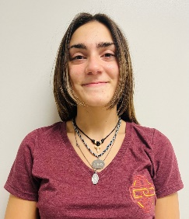
Haley Aversa is a junior from Mamaroneck, New York majoring in Arts Leadership with a dance concentration. This is her fifth semester in dance ensemble. She has been dancing since she was 18 months old and has experience in multiple styles of dance including: Lyrical, Hip Hop, Ballet, Contemporary, Jazz, and Modern.
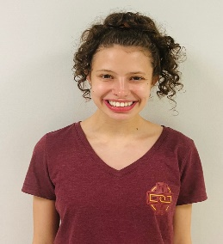
Samantha D'Agostino is a sophomore from Long Island, NY majoring in Speech Pathology. This is her second semester with the Iona University Dance Ensemble. She has been dancing for sixteen years and has been trained in various styles including ballet, jazz, lyrical, contemporary, modern, and musical theatre. Samantha would like to thank Dr. Park for this great opportunity to continue her dance training at Iona.

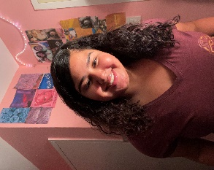Darianny Mercedes is a freshman from Bronx, New York majoring in nursing and minoring in dance. This is her first semester with the Iona University Dance Ensemble. Darianny has been dancing since she was 15 and has danced in different genres for example salsa and hip-hop. She’s pursuing her bachelors to become a travel nurse and potentially a neonatologist. She likes how she can show her Dominican roots through dances like bachata, merengue, reggaeton. Dance is a way she lets loose and just feels the music and enjoys it.
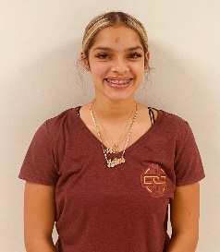
Aaliah Morales is a sophomore from the Bronx, New York majoring in Arts Leadership with a dance concentration. This is her first semester with the Iona University Dance Ensemble. Aaliyah has been dancing since the age of three and has danced in various styles including Contemporary, Hip Hop, Jazz, Salsa, Bachata, Bollywood, Musical Theater, and Ballet. She enjoys being on stage and performing. Her favorite genres are Salsa, Bachata, and Contemporary. As of January 2020, Aaliyah is a World Salsa Summit champion.
Ariel Posner is a freshman from New Rochelle, NY majoring in Criminal Justice and minoring in dance. She has been dancing since she was young and has been exposed to many dance forms including jazz and modern/contemporary. She enjoys choregraphing various solos which she did through her high school dance program. This is her first semester with the Iona University Dance Ensemble.

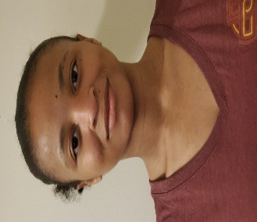
Jennifer Romain is a senior from Haiti majoring in Art leadership with dance concentration. This is her fifth semester with the ensemble. She has been dancing for over ten years and has experience in Jazz, hip-hop, modern, and lyrical.

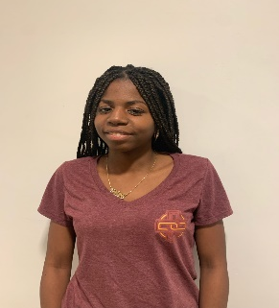
Christele Romulus is a senior from Brooklyn, NY majoring in Psychology and minoring in dance. This is her first semester with the Iona University Dance Ensemble. She has been dancing for about 17 years. She has experience in many styles including Afro-Caribbean, Folklore, Jazz, Hip-Hop, Choreography, and majorette. She is also involved with the BSU dance experience as a dance captain and serves as a president and secretary for Lambda Theta Alpha Latin Sorority, Incorporated.
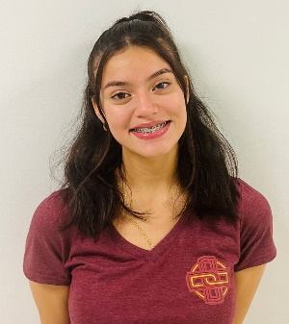
Kayla Torres is a freshman at Iona majoring in psychology. This is her first semester with the Iona University and what she admires about the art of dance is how it can be a source for creativity and expressing yourself.

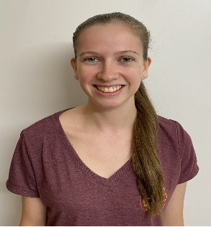
Victoria Shinnick is a senior from Long Island, NY majoring in early childhood/ childhood education and minoring in dance. This is her fourth semester with the ensemble. She has been dancing for seventeen years and has been trained in various styles including ballet, jazz, lyrical, tap, hip hop, pointe, and kick line. She is also on the Iona College Dance Team and currently serves as its events and community service chair.
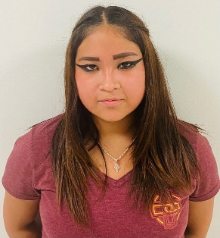
Ariana Tamayo is a freshman from New Rochelle, NY majoring in Finance. This is her first semester with Iona University Dance Ensemble. She has been dancing since the age of eight and has danced in Hispanic genres such as bachata, salsa, and modern dance. Ariana is part of BCS "Bailando con Sazon" to demonstrate her abilities in Hispanic dance at Iona University.
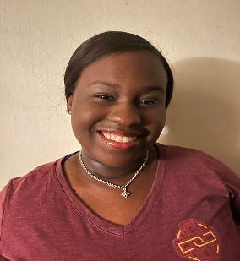
Aamirah West is a freshman from the Bronx, New York. She is a minoring in dance and majoring in arts leadership. She starting dancing at 4 years old and enjoys many forms of dance. She has studied hip-hop, modern, lyrical and African dance. She was captain of Gifted’ Elite Performance Arts Team. She is a member of the BSU Dance Team. This is her first-year dancing with the Iona University Dance Ensemble.

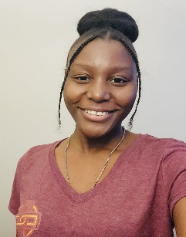Avia Willis is a freshman from Jamaica, now commuting from Mount Vernon. She majors in Biology with a concentration in Pre-Medicine. This is her first semester with the Iona University dance ensemble. She is the community service chair for the commuter student association and a member of Bailando Con Sazon. She has no previous dance experience but has always desired to perform through an expression of movement.

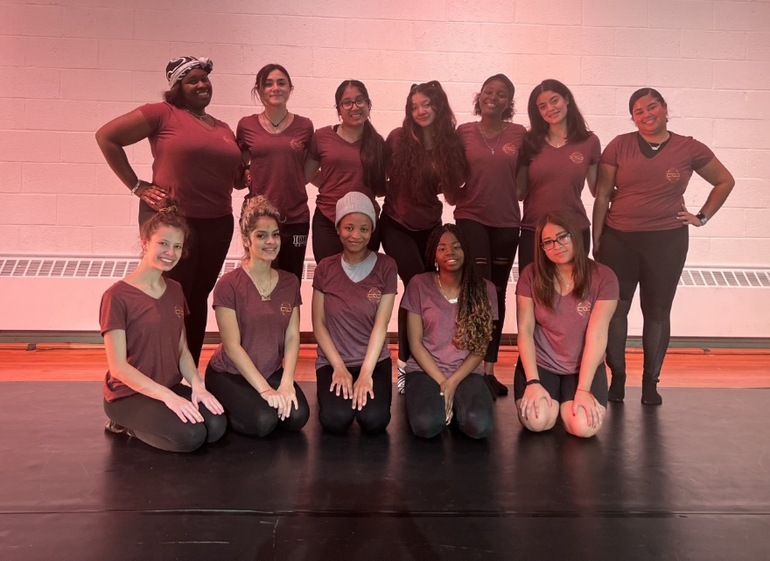
IUDE Fall 2022 Dancers posing.
From Left to Right:
Back Row: Aamirah West, Haley Aversa, Leslie Aguirre, Ariel Posner, Avia Willis, Kayla Torres, Darianny Mercedes,
Front Row: Samantha D’Agostino, Aaliah Morales, Jennifer Romain, Christele Romulus, Ariana Tamayo
*Not pictured: Victoria Shinnick

Dance Faculty

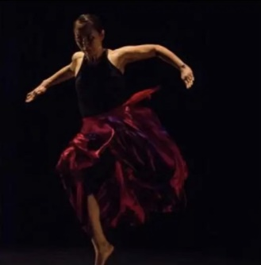 Dr. Hannah Park, director of the dance program and the Iona University Dance Ensemble, is an educator, performer, choreographer, and scholar who has performed works by Jose Limon, Martha Graham, Mark Morris, Neil Greenburg, Kay Cummings, Gus Solomon Jr., Kun-Yang Lin, Jin-Wen Yu, Lisa Kraus, Philip Grosser, Ananya Dance Theatre, Lori Belilove, and the Isadora Duncan Dance Company, among others. Her choreographic works have debuted in both in the States and in Korea, and she has presented papers and workshops nationally and internationally including conferences at the National Dance Education Organization, National Dance Association, American College Dance Association, International Association of Dance Medicine and Science, Dance and the Child International (daCi), and Body Mind Centering Association. She currently serves as a consultant for NY State Education Department’s Assessment in Dance and the Korean International Society of Dance Studies.

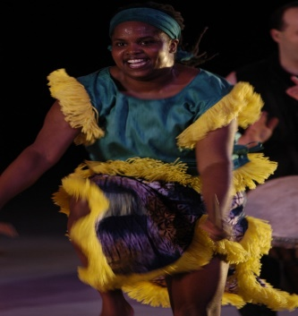

Prof. Andrea Markus (Kingston, Jamaica) received her MA in Dance Education from New York University's Steinhardt School of Culture, Education and Human Development. She also studied dance at Ballet School New York, Ithaca College, Dance New Amsterdam and The Limon Institute and is a doctoral candidate in dance education at Columbia University’s Teachers College’s Dance Education Masters Program. Andrea has traveled to Guinea, West Africa to study dance and drumming with members of the national companies Les Ballets Africains de Guinea and Ballet Djoliba. She has performed with the Alpha Omega 1-7 Theatrical Dance Company, performing dance works by George Faison, Eleo Pomare, and more. Andrea has also danced and co-directed Magbana Drum & Dance NYC, a West African-based performance group of percussionists and dancers. She has taught dance to students in grades preK-12 as a teaching artist for 92nd Street Y/Dance Education Laboratory, Young Audiences of New York, and Alvin Ailey Arts In Education & Community Programs. She is currently a teaching artist for Ailey Arts In Education & Community Programs, ArtsConnection, a faculty member of Iona University, Marymount Manhattan's Department of Dance, New York University's Department of Music and Performing Arts Professions, and the Ailey School.

Guest Artist/Choreographer
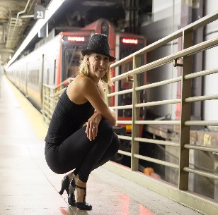
Originally from Ottawa, Canada, Lisa Harvie is a New York City based dancer, educator and choreographer. She holds her MFA in Dance from Montclair State University and is a graduate of the University of Toronto. She is a member of Actors Equity and of the Royal Academy of Dance (A.R.A.D.).
Ms. Harvie is an established faculty member at Steps on Broadway, teaching for both the open Professional Division and for the Steps Youth Program. She is also on faculty at Vassar College and is a guest jazz choreographer at Iona College. She has taught at NYU's Strasberg Institute, Joffrey Ballet School, The School at Columbia, Connecticut Dance Conservatory, Cumbrae Dance Center, and has given master classes for the Open Jar Institute, Verb Ballets, Destination Broadway, the British Association of Dance, and the Elan Awards in New York City. She has acted as Associate Choreographer at the Gateway Playhouse (NY) and choreographed for the Foolish Theater Company in New York City. She has showcased a multitude of original pieces at Steps on Broadway and has worked with high school theater programs in setting full-length musical productions.
National and regional performance credits include West Side Story, My Fair Lady, Carousel, Singin' in the Rain, Oklahoma, Footloose, Kiss Me Kate, and Scrooge. Lisa performed at the Hudson Theater in a tribute to the late Broadway producer David Merrick, with choreography set by Karin Baker. She worked with Patricia Wilcox for the 20th Anniversary Concert Performance of Rags at the Nokia Theater, and appeared in the New York workshop production of The Great White Way, directed and choreographed by David Marquez. In addition to her work in musical theater, she has danced with the Ottawa Ballet at Canada's National Arts Center.

Create, Explore, and Discover through Dance…

FPA340 (1 Credit)

Official Course for the Iona College Dance Ensemble

Fall/Spring

*Requirement for obtaining Arts Leadership major with dance concentration and/or dance minor

For more information on the dance ensemble, arts leadership with dance concentration, and dance minor, contact:
Dr. Hannah Park at hpark@iona.edu.

Special Thanks & Acknowledgement

      - President of Iona University, Dr. Seamus Carey
      - Interim Provost, Dr. Tricia Mulligan
      - Dean of The School of Arts and Science, Dr. Joseph Stabile
      - The Iona Council on the Arts Members
      - Chair of Arts & Languages Department, Dr. Thomas Mussio
      - Arts & Languages Department Faculty Members
      - Prof. Andrea Markus from the Dance Program
      - Prof. Lisa Harvie, Guest Choreographer
      - Mr. Rick Palladino
      - Mr. Aidan Callahan, Mr. Blake Kinney and the IT Department
      - Media Relations
      - Becca Schmit – Lighting Design
      - Dr. Gillean Lee – Videography

Iona University
715 North Avenue
New Rochelle, NY 10801 www.iona.edu

Learn Outside The Lines

